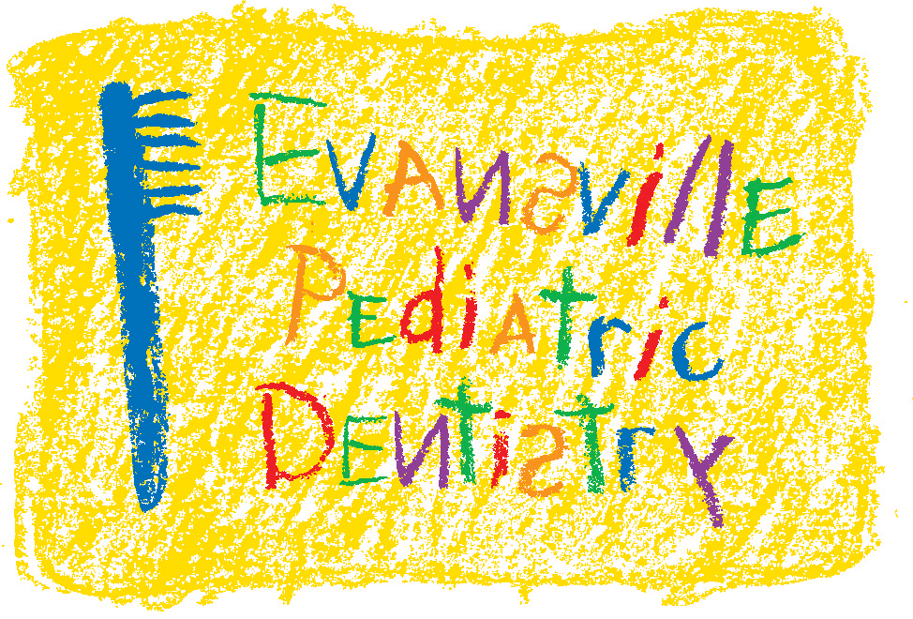
Jeffrey A. Hiester, D.D.S.
EAST WEST
7200 E. Virginia Street 2345 W. Franklin Street #101
Evansville, IN 47715 Evansville, IN 47712
(812) 479-8609 (812) 401-6095

